Hosting website on CentOS VM using Vagrant (Windows Guest OS)
Pre-requisites:
1. Vagrant
Steps:
- Make directory in your preferred drive
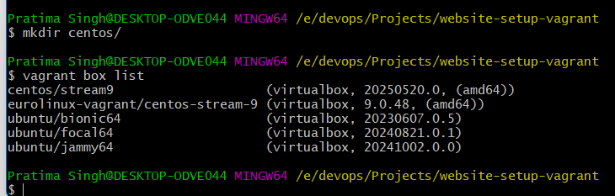
- Create VagrantFile in your directory
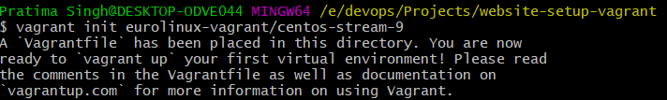
- Open VagrantFile using vim and get into Insert mode
- Uncomment private and public network configuration lines. Assign a static private IP
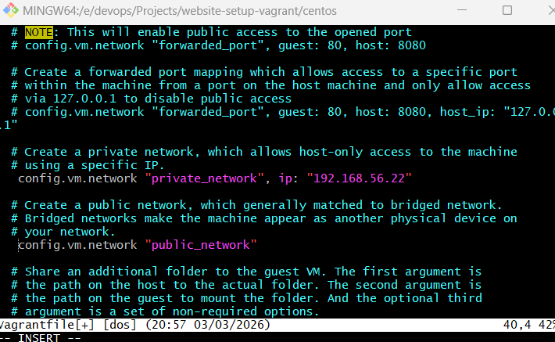
- Uncomment Virtualbox(hypervisor) memory
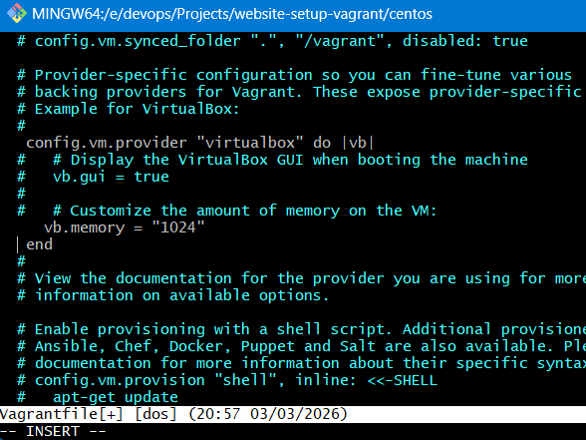
- Save and quit after getting into extended mode.
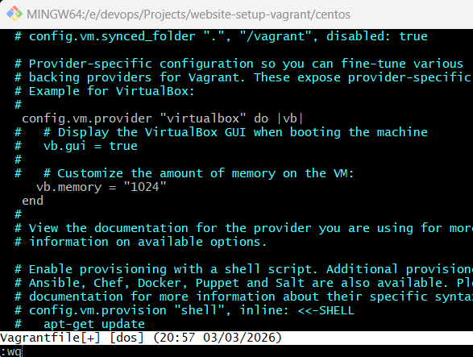
- Turn up the VM
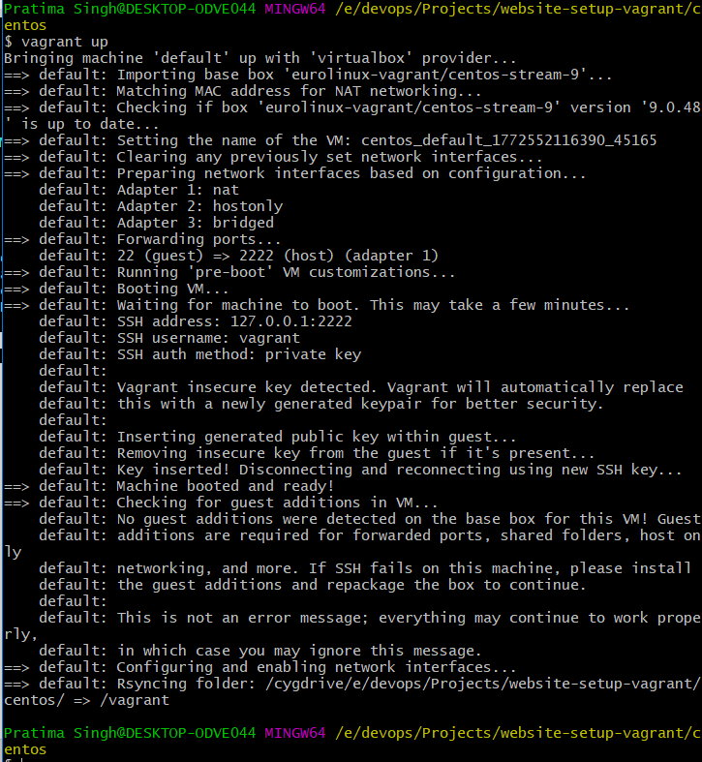
- Login to the VM
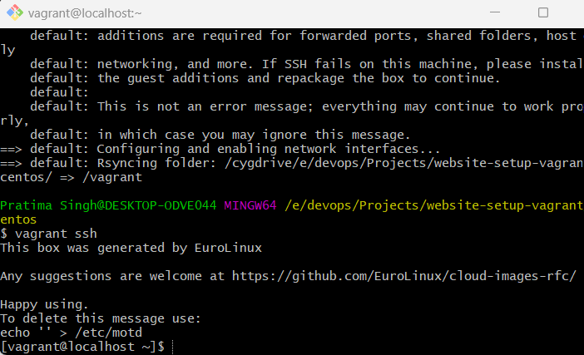
- Switch to root user
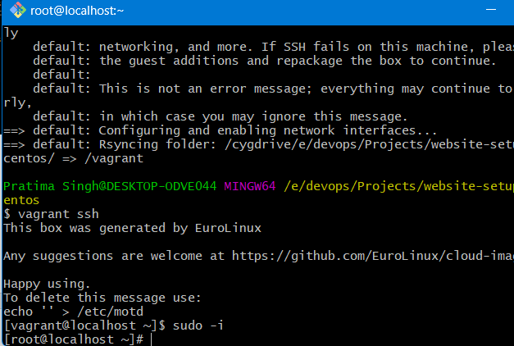
You can change the hostname by editing /etc/hostname file, using vi editor
- Install following packages:
- httpd (for Centos, for Ubuntu-> Apache2 package): Contains HTTP server for hosting website
- wget: retrieving files from the web using the HTTP, HTTPS, and FTP protocols
- vim: text editor
- unzip: package to unzip compressed files
- zip: package to compress files into zip file
- Start and enable httpd service
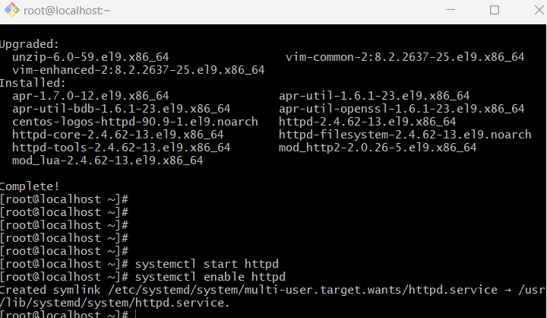
- Check private IP address
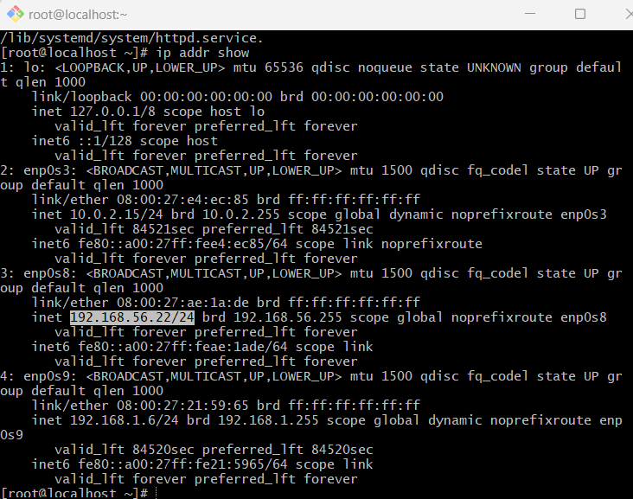
- Enter the URL in any browser: http://<IP-address>
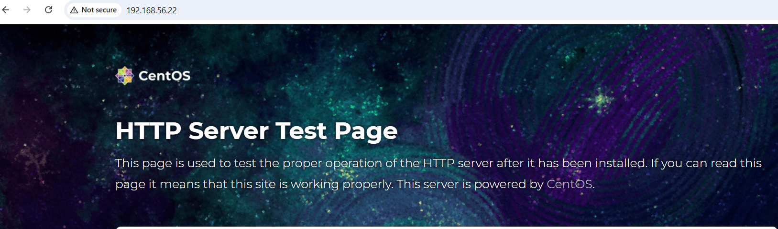
- Rewrite all your website files in /var/www/html
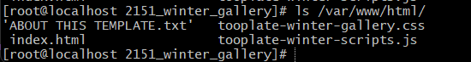
- Restart httpd service
- Check status of the httpd service
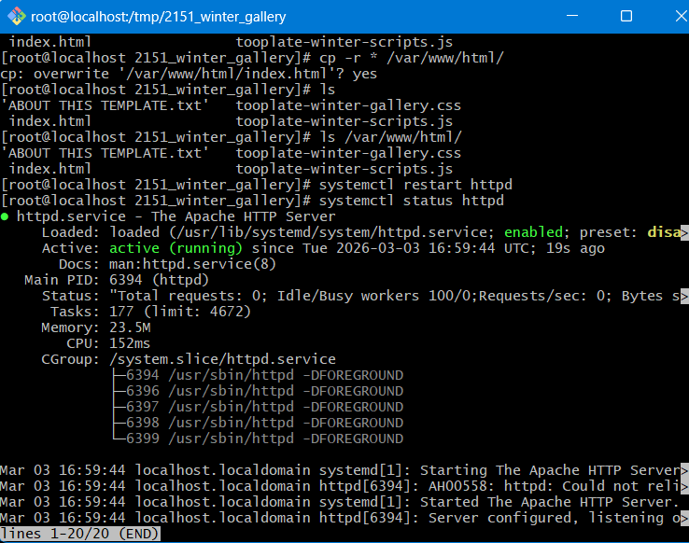
- Check firewalld service is disabled by default
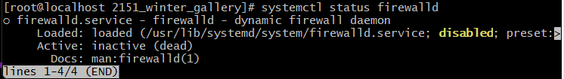
Note: on Fedora or MacOS, this will be enabled by default
- Refresh the same page on browser


